- Create VPC with 2 private and 2 public subnets.

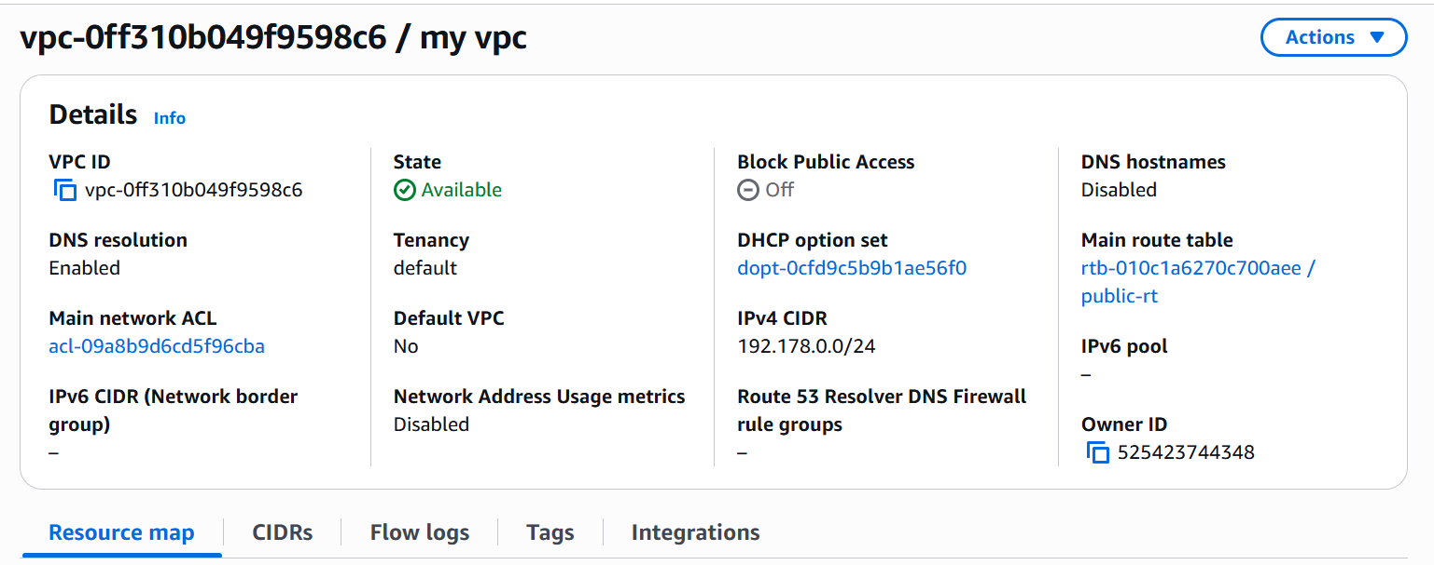

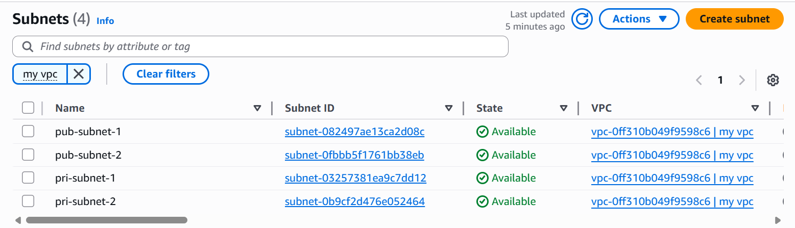

- Enable DNS Hostname in VPC

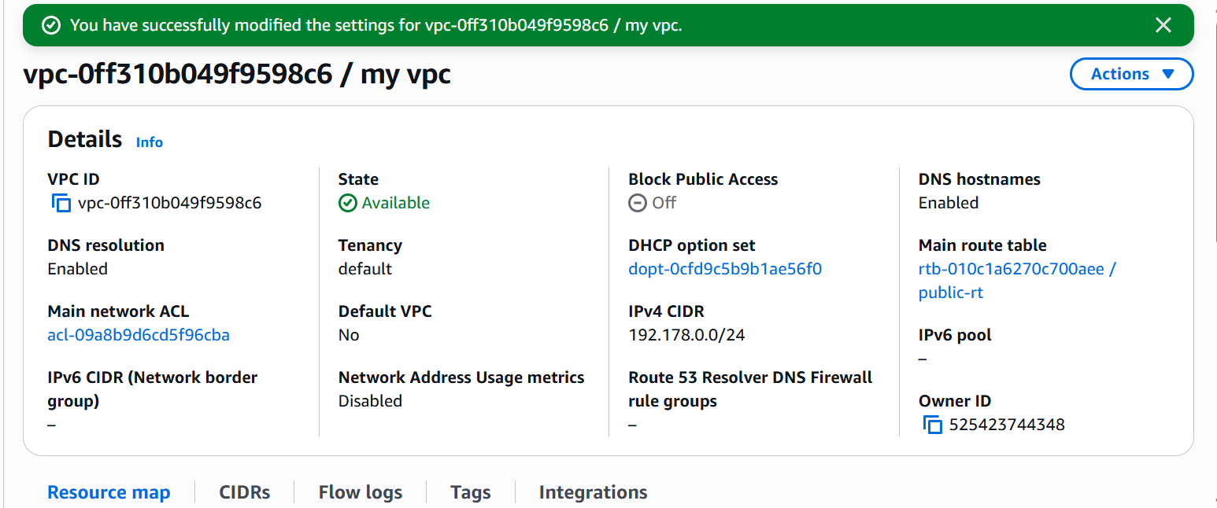

- Enable Auto Assign Public ip in 2 public subnets

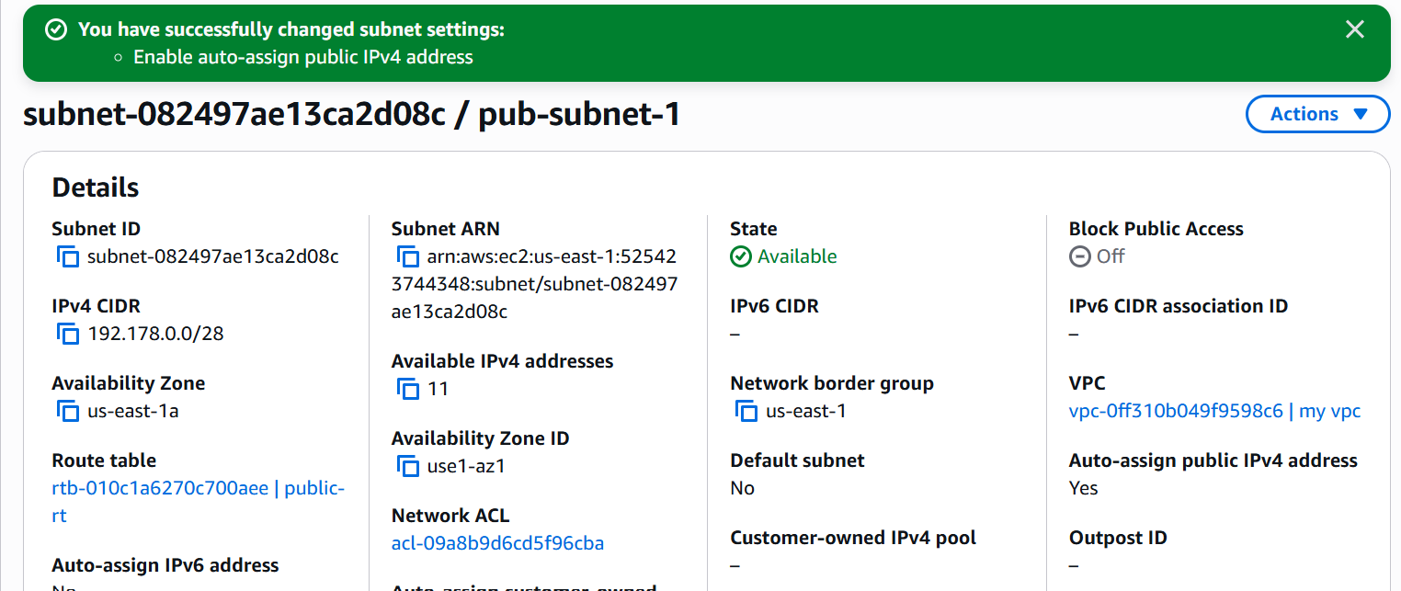

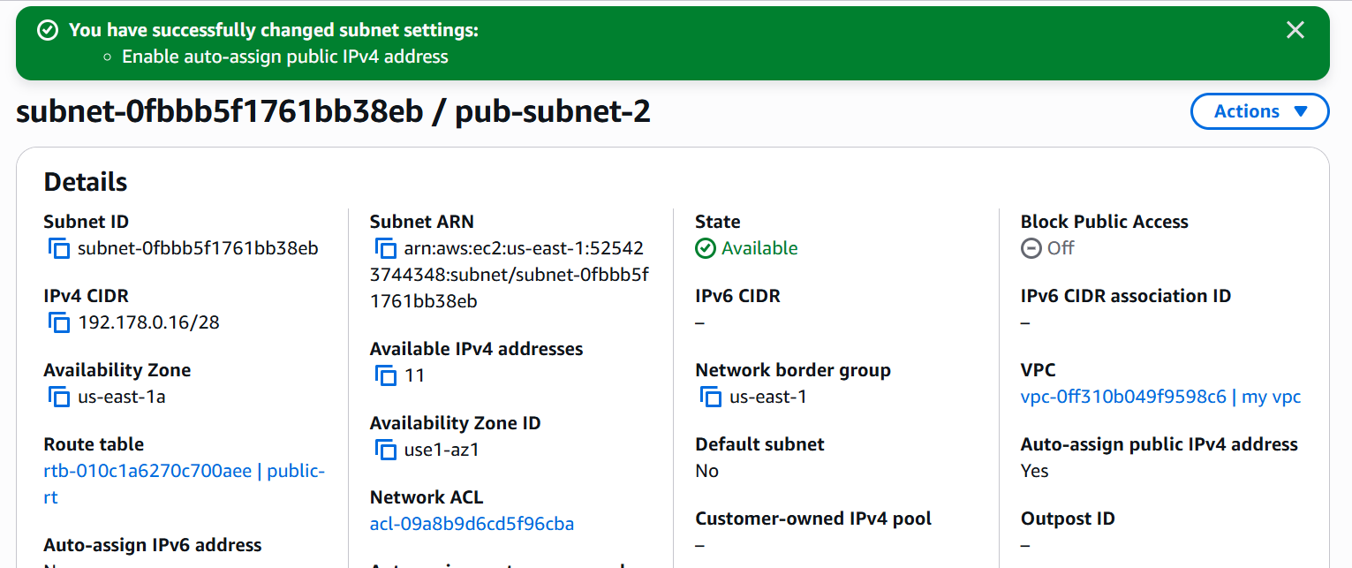

- Add 2 private subnets in private route table

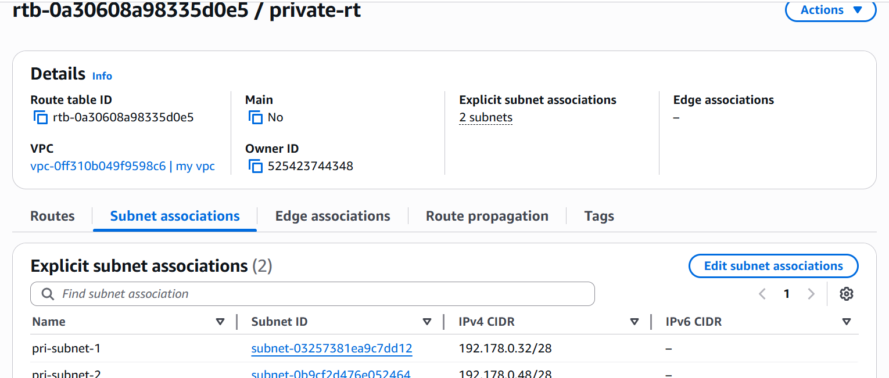

- Add 2 public subnets in public route table

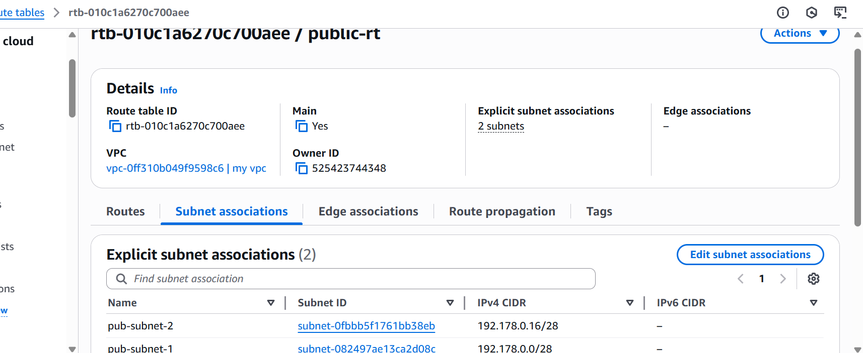

- Public route table will have the routes to internet and local

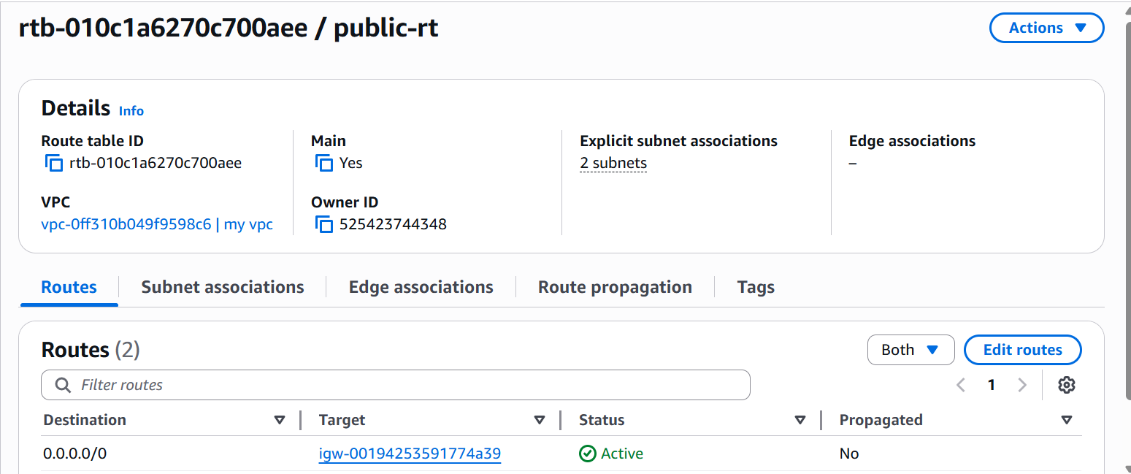

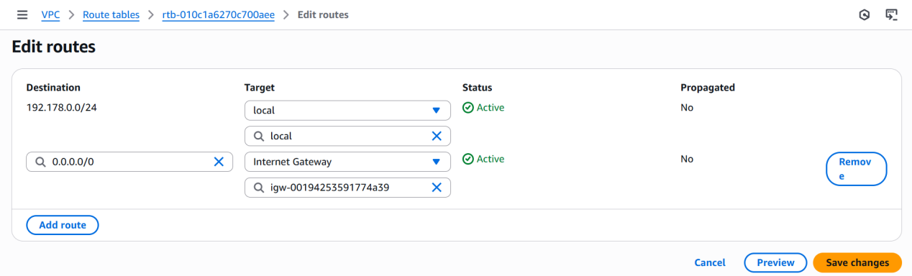

- Create Ec2 in public subnet with t2micro and install php
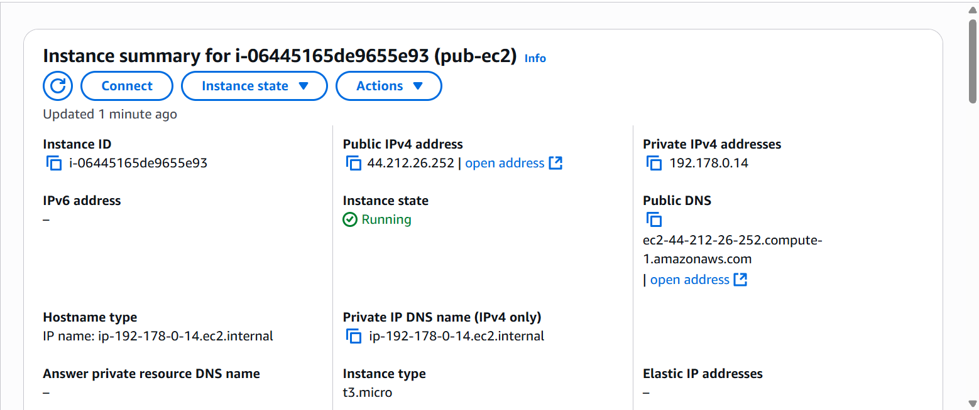
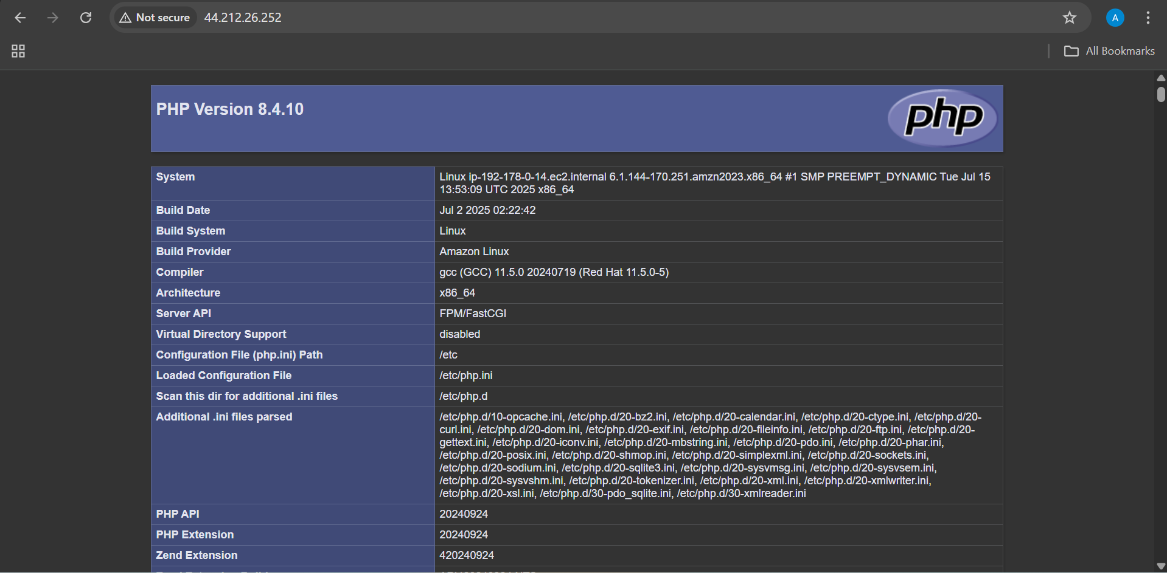

- Configure Nat gateway in public subnet and connect to private Instance

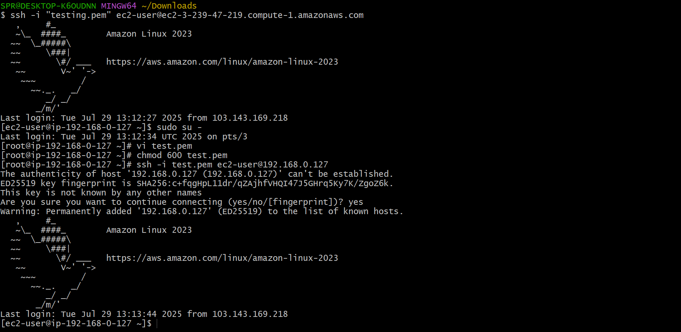

- Install Apache Tomcat in private ec2 and deploy a sample app.

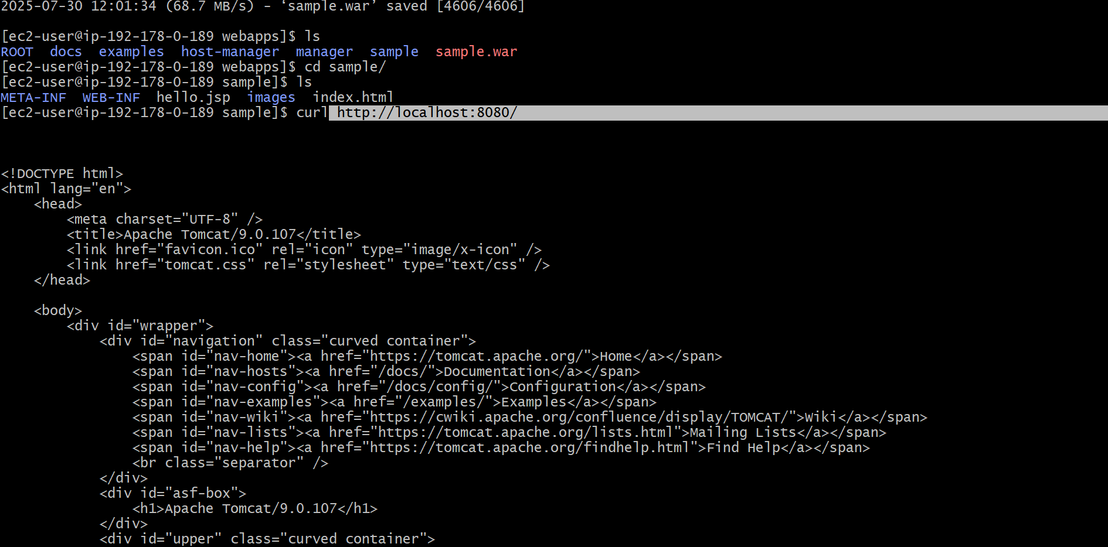

- Configure VPC flow logs and store the logs in s3 and CloudWatch.

S3 llogs
